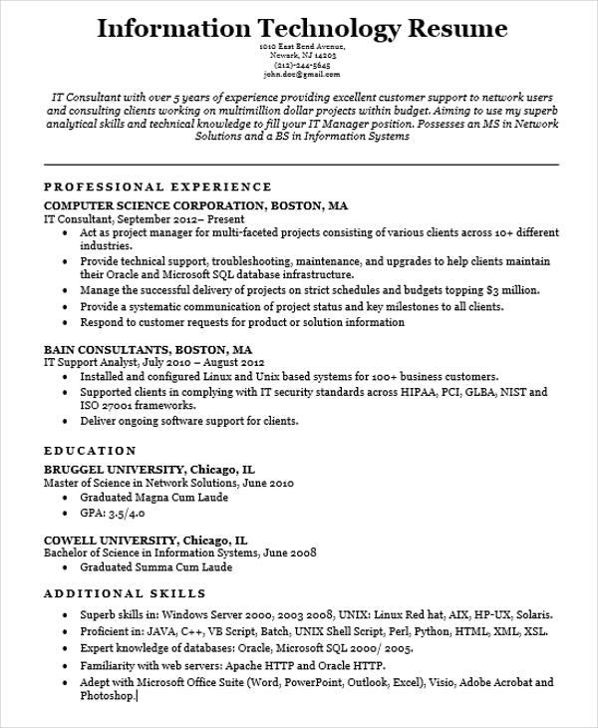
Information Technology Resume
1010 East Bend Avenue, Newark, NJ 14203 (212)-244-5645 john.doe@gmail.com
IT Consultant with over 5 years of experience providing excellent customer support to network users and consulting clients working on multimillion dollar projects within budget. Aiming to use my superb analytical skills and technical knowledge to fill your IT Manager position. Possesses an MS in Network Solutions and a BS in Information Systems
PROFESSIONAL EXPERIENCE
COMPUTER SCIENCE CORPORATION, BOSTON, MA
IT Consultant, September 2012- Present
• Act as project manager for multi-faceted projects consisting of various clients across 10+ different industries.
• Provide technical support, troubleshooting, maintenance, and upgrades to help clients maintain their Oracle and Microsoft SQL database infrastructure.
• Manage the successful delivery of projects on strict schedules and budgets topping $3 million.
• Provide a systematic communication of project status and key milestones to all clients.
• Respond to customer requests for product or solution information
BAIN CONSULTANTS, BOSTON, MA
IT Support Analyst, July 2010 - August 2012
• Installed and configured Linux and Unix based systems for 100+ business customers.
• Supported clients in complying with IT security standards across HIPAA, PCI, GLBA, NIST and ISO 27001 frameworks.
• Deliver ongoing software support for clients.
EDUCATION
BRUGGEL UNIVERSITY, Chicago, IL
Master of Science in Network Solutions, June 2010
• Graduated Magna Cum Laude
⚫ GPA: 3.5/4.0
COWELL UNIVERSITY, Chicago, IL
Bachelor of Science in Information Systems, June 2008
• Graduated Summa Cum Laude
ADDITIONAL SKILLS
• Superb skills in: Windows Server 2000, 2003 2008, UNIX: Linux Red hat, AIX, HP-UX, Solaris. • Proficient in: JAVA, C++, VB Script, Batch, UNIX Shell Script, Perl, Python, HTML, XML, XSL. • Expert knowledge of databases: Oracle, Microsoft SQL 2000/2005.
• Familiarity with web servers: Apache HTTP and Oracle HTTP.
Adept with Microsoft Office Suite (Word, PowerPoint, Outlook, Excel), Visio, Adobe Acrobat and Photoshop

